RAJALAKSHMI ENGINEERING COLLEGE

**RAJALAKSHMI NAGAR, THANDALAM – 602 105**



|  |
| --- |
| **CS23A34**  **USER INTERFACE AND DESIGN LAB** |
| **Laboratory Observation NoteBook** |

**Name :SRIVATHSAN N**

**Year/Branch/Section :** II/CSE/F **Register No. :** 230701343 **Semester :** IV

**Academic Year:** 2024-25

**Ex. No. : 1a Date:22/1/25**

**Register No. : 230701343 Name : Srivathsan N**

**Introduction to Figma (GOOD and BAD Design)**

**Aim:**

To use Figma to create a simple mobile app login screen, including basic design and prototyping.

**Procedure:**

# Step 1: Sign Up and Create a New Project

1. Go to figma.com and create an account (if you haven’t already).
2. Once logged in, click “New File” to start a blank project.

# Step 2: Create the Frame (Artboard)

1. On the left toolbar, select the “Frame” tool (shortcut: F).
2. Choose a mobile preset (e.g.,iPhone 13) from the righthand panel.

# Step 3: Design the Login Screen Add a Background Color:

1. Select the frame and go to the right-side panel.
2. Under “Fill” choose a background color (e.g., light blue).

# Insert a Logo:

1. Click the “Rectangle” tool (shortcut:R) and draw a placeholder for a logo.
2. Use the “Text” tool (shortcut: T) to add your app name, e.g., “MyApp”.
3. Adjust font size and color from the right-hand panel.

# Add Input Fields:

1. Use the “Rectangle” tool to draw two boxes for username and password fields.
2. Add placeholder text inside (e.g., “Enter your email”).
3. Apply rounded corners under “Corner Radius” in the right panel.

# Add a Login Button:

1. Create a button using the Rectangle tool and set the color to blue.
2. Use the Text tool to add the text Login inside the button.

# Align Elements:

Use the alignment tools in the top menu (center everything vertically and horizontally).

Adjust spacing between elements using the Auto Layout feature (Shift + A).

# Step 4: Prototyping the Interaction

1. Click the Prototype tab on the right panel.
2. Select the Login button and drag the blue dot to a new frame (e.g., a home screen).
3. Set the interaction to On Click → Navigate to the next screen.
4. Choose an animation effect (e.g., Smart Animate).

# Step 5: Preview the Design

1. Click the Play button in the top-right corner to preview your app prototype.
2. Try clicking on the login button to see the transition to the next screen.

# Step 6: Export Assets

1. Select the elements you want to export (e.g., the logo or button).
2. In the right-hand panel, click &quot;Export&quot; and choose a format (PNG, JPG, SVG).
3. Click “Export” to download assets for developers.

**OUTPUT :**

# BAD DESIGN:

This login page has a poor design due to several issues:

The use of **“Log In”** and **“Sign In”** together is confusing—both usually mean the same thing. It should be **“Log In”** and **“Sign Up.”**

The **“Log In”** button appears on the Sign-Up screen too, instead of changing to **“Sign Up”** or **“Register.”** This can confuse users about what action they are performing.

The **Google, Twitter, and Facebook** options are just small, plain text links. They’re hard to tap and not visually identifiable as buttons or interactive elements.

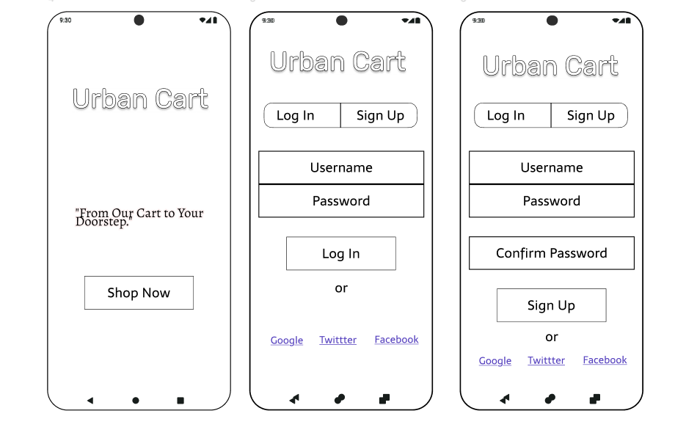

# GOOD DESIGN :

This login page has a good design due to several factors:

• **Clean and modern look** with a blurred background for focus.

• **Buttons and fields** are clear, consistent, and easy to tap.

• **Social login icons** are colorful, recognizable, and user-friendly.

• **Navigation is clear** with proper labels and toggle highlights.

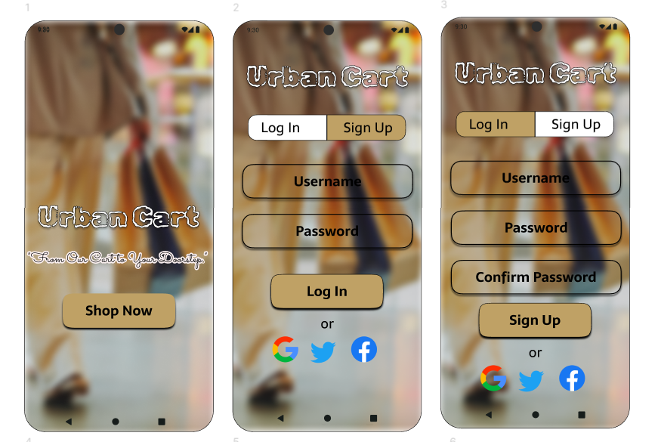

**Result:**

Hence the introduction to figma with good and bad design has been successfully studied and executed.